**Duologues & Scenes**

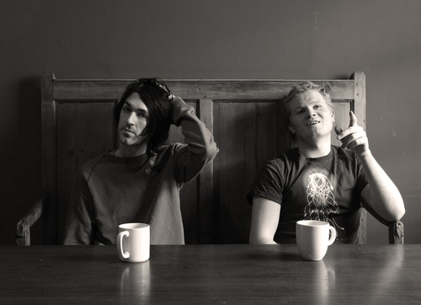

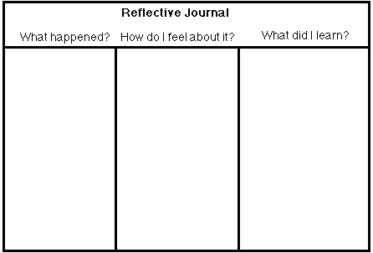**NAME___________________________________________________**

**CLASS___________________________________________________**

**LESSON 1**



**LESSON 2**

**LESSON 3**

**LESSON 4**

**LESSON 5**

**LESSON 6**

**LESSON 7**

**LESSON 8**

**LESSON 9**